

FEA Lab Project Report
Title: Static and Transient Structural Analysis of a Simple Polygon Structure

Course: Finite Element Analysis Lab Student Name: Saim Aslam
Roll Number: ME-1890



Introduction
The objective of this project is to perform Static and Transient structural simulations on a simple geometric structure using ANSYS. The material properties, boundary conditions, loading criteria, and simulation parameters are defined based on my roll number and date of birth.
This report documents the modeling procedure, material assignment, boundary conditions, meshing, simulation settings, mesh convergence study, and results for both static and explicit simulations.
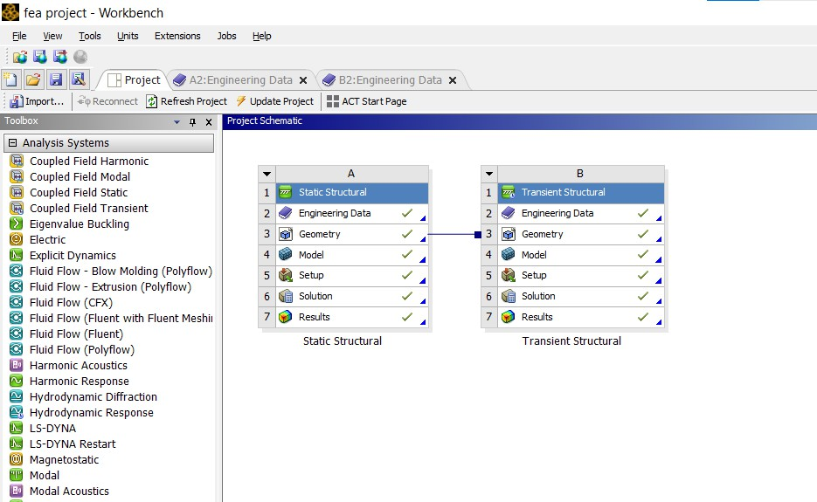

Problem Definition
  - Geometry Selection
- Selected Shape: (Pentagon, roll number 1890 – Even number)
- Geometry was created in Solidworks.

  - Material Properties
Material properties were assigned based on: - Elastic Modulus (E): 90× 10,000 MPa -
Poisson’s Ratio (ν): 0.28
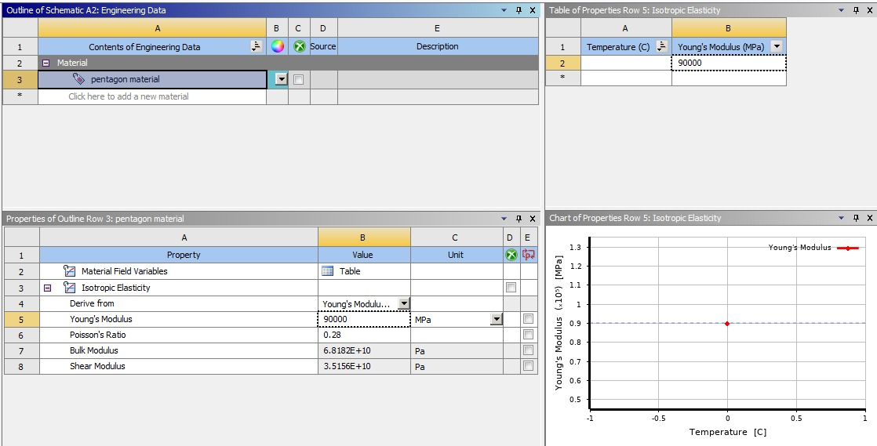
  - Boundary Conditions
- One face of the pentagon is fully fixed.
- A Remote Force is applied at 1/3rd length of the fixed face.
- Magnitude of force = Sum of digits of Date of Birth i.e 2033 ( 19th october 2004)
  - Explicit Analysis Loading Criteria
- Time step: 0.2 seconds
- Applied force = 280.66

Geometry and Modeling
A Pentagon was sketched and extruded to required thickness. The orientation was selected such that one complete face lies horizontally for fixing and ease of force application.

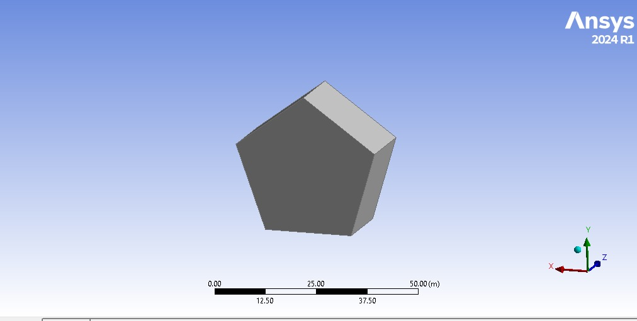

Meshing
Meshing plays a crucial role in the accuracy of FEA simulations. The following mesh types were used: - Element Type: hexagonal
A mesh convergence study was performed for static structural analysis only as there isn’t
any option of mesh convergence in transient structural analysis.
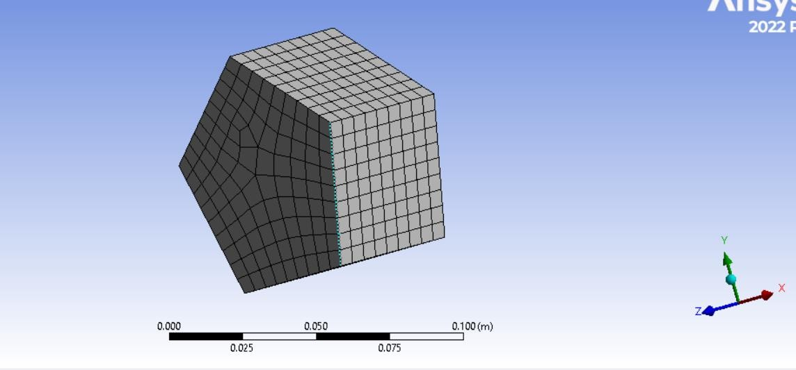

Static Structural Simulation

Boundary Conditions
- Fixed Support: One face fully constrained.
- Remote Force: Applied at 1/3rd region of fixed face.

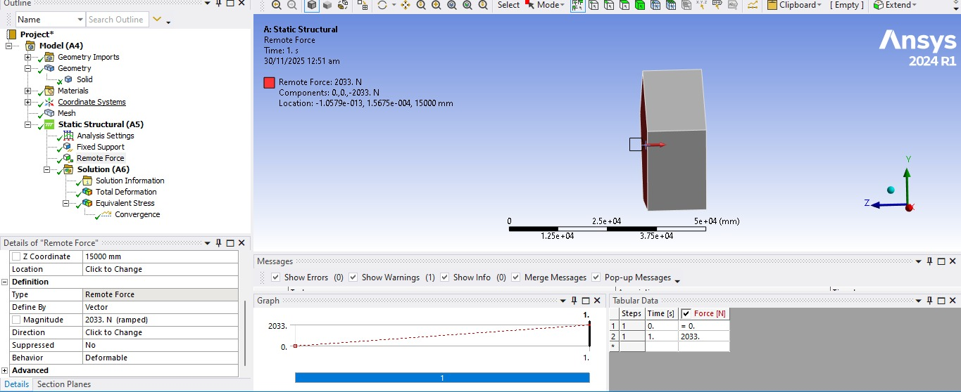

Results
    - Total Deformation

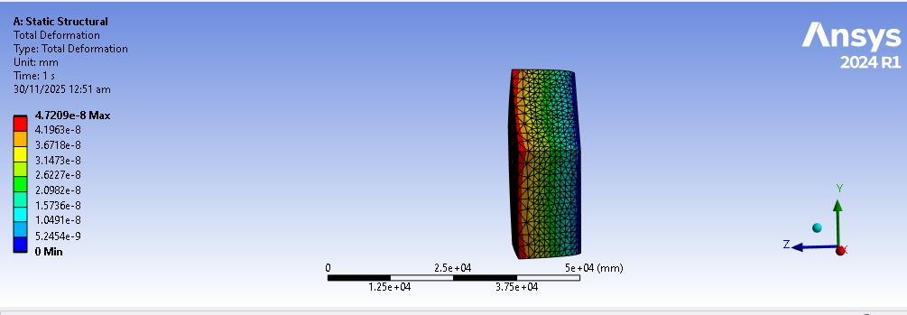

    - Equivalent Stress (von Mises)
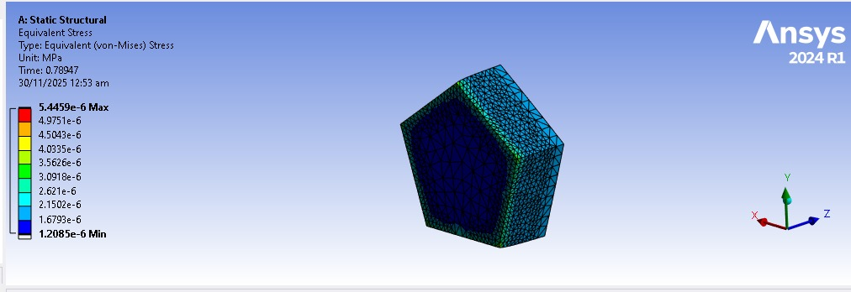

  - Mesh Convergence (Static)

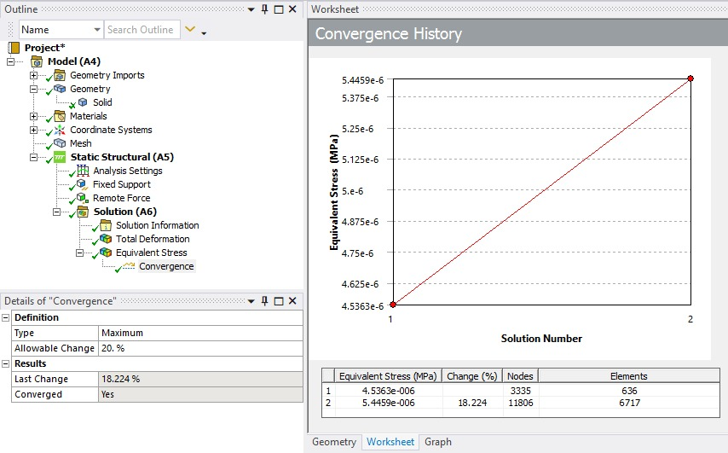

Transient Structural Simulation

Loading and Time Setup
For this project, the transient (explicit type) simulation was performed using 5 time steps, each having a step size of 0.2 seconds, resulting in a total simulation time of 1.0 second.

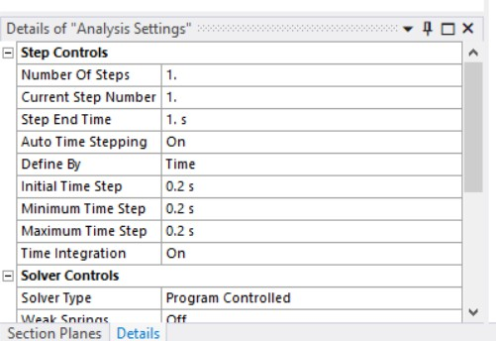

Force Input Method
Instead of a single constant force, the applied force at each time step was taken from the peak force values extracted from the USD to PKR exchange-rate graph of the day.
These peak values were mapped into the load curve for the 5 simulation steps.
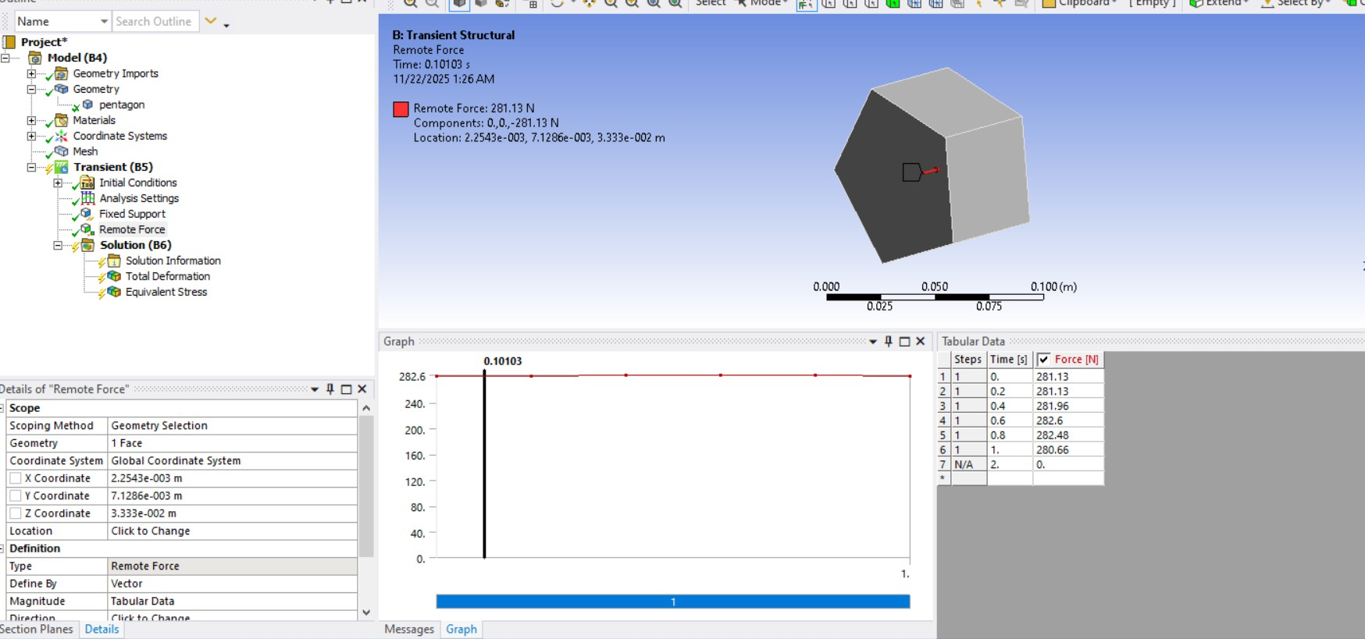

Results
    - Deformation vs Time

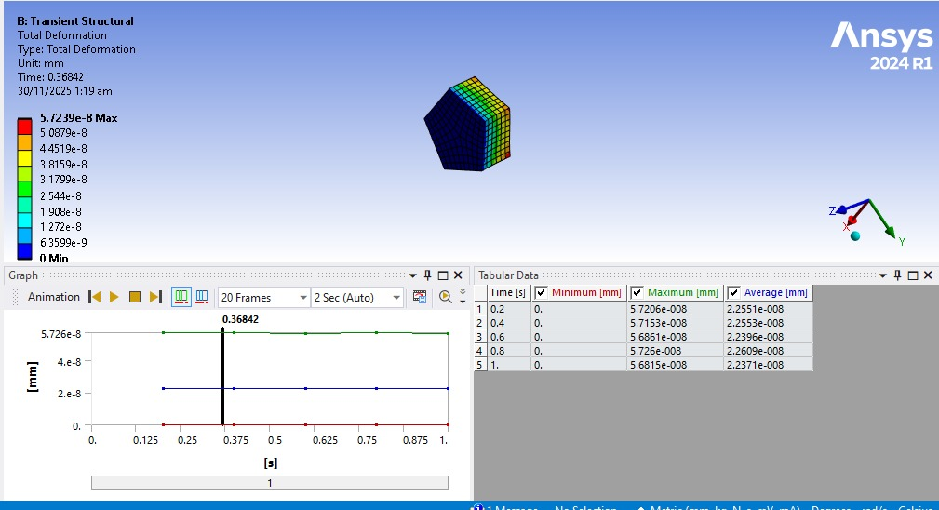

    - Stress-Time Response

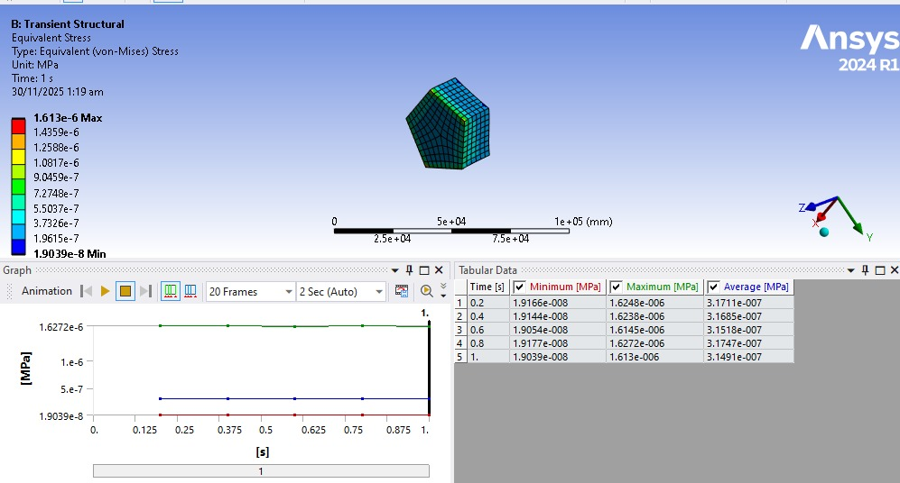

    - Strain Energy

